**PING PONG GAME USING ARDUINO**

**MICROPROJECT REPORT**

**5th Semester**

Submitted by

**NANDANA KRISHNA P B**

Reg No:MAC22EE077

**NANDHANA M J**

Reg No:MAC22EE079

**NIRANJAN RAJEEV**

Reg No:MAC22EE082

**MICROPROCESSORS AND MICROCONTROLLERS LAB**

**(EEL331)**



**Department of Electrical and Electronics Engineering**

Mar Athanasius College of Engineering

Kothamangalam

September 2024

1

**DEPARTMENT OF ELECTRICAL AND ELECTRONICS ENGINEERING**

**MAR ATHANASIUS COLLEGE OF ENGINEERING KOTHAMANGALAM**



**CERTIFICATE**

This is to certify that the report entitled **Ping Pong Game Using Arduino** submitted by **Ms. NANDANA KRISHNA P B (Reg.No.MAC22EE077), MS.NANDHANA M J (Reg.No.MAC22EE079), Mr. NIRANJAN RAJEEV (Reg.No.MAC22EE082)** to the APJ Abdul Kalam Technological University in partial fulfilment of the requirements for the award of the Degree of Bachelor of Technology in Electrical & Electronics Engineering is a bonafide record of the micro project carried out by her under our guidance and supervision. This report in any form has not been submitted to any other University or Institute for any purpose.

Prof. Neetha John Dr. Siny Paul

Micro Project Coordinator Head of the Department

Assistant Professor Electrical and Electronics Engineering

Department Seal

Date: 23/09/2024

**ACKNOWLEDGEMENT**

It is a great pleasure to acknowledge all those who have assisted and supported us for

successfully completing our project.

First of all, we thank God Almighty for his blessings as it is only through his grace that we were able to complete our project successfully.

We also extend our sincere thanks to our micro project coordinator, Prof. Neetha John, Assistant Professor, Department of Electrical & Electronics Engineering and all other members of the Department of Electrical & Electronics Engineering for sharing their valuable comments about our microproject.

We take this opportunity to extend our sincere thanks to our faculty advisor, Prof. Jeena Joy, Associate Professor, Department of Electrical & Electronics Engineering for her constant support and immense contribution for the success of our microproject.

We are also grateful to Dr. Siny Paul, Head of Electrical & Electronics Engineering Department for her valuable guidance as well as timely advice, which helped us a lot in the preparation of our microproject.

We are deeply indebted to Dr. Boss Mathew K, Principal, Mar Athanasius College of

Engineering, for his encouragement and support.

We wholeheartedly thank all our classmates for their valuable suggestions and the spirit of healthy competition that existed among us.

3

**ABSTRACT**

The microproject introduces a two-player Pong game developed using an Arduino UNO, a 0.96-inch OLED SSD1306 display, and push buttons. The game demonstrates fundamental Arduino concepts such as interfacing with sensors, handling digital inputs and outputs, and real-time interaction. Players control paddles using push buttons to keep the ball in play, with the game providing visual feedback on the OLED screen. The microproject entails setting up the game with necessary libraries like SSD1306 and Adafruit GFX in the Arduino IDE. The system's simplicity and the use of readily available components make this project both accessible and engaging. We gain practical skills in connecting hardware, writing and uploading code, and troubleshooting.Through this hands-on experience, the project enhances understanding of microcontroller-based projects and the integration of multiple electronic components. It serves as an excellent introduction to the principles of Arduino programming. The microproject ensures foundational knowledge in electronics and programming while enjoying a fun and interactive project.

**CONTENTS**

Chapters Page No.

**CHAPTER 1. INTRODUCTION 7**

**CHAPTER 2. METHODOLOGIES 8**

2.1 Block diagram 8

2.2 Components required 9

2.3 Circuit diagram 10

**CHAPTER 3. SIMULATION 11**

3.1 Simulation 11

3.2 Program code 14

**CHAPTER 4. ADVANTAGES AND LIMITATIONS 17**

4.1 Advantages 17

4.2 Limitations

**CHAPTER 5. CONCLUSION 18**

**REFERENCES 19**

**LIST OF FIGURES**

Figures Page No.

Fig 2.1 Block diagram of ping pong game using arduino 8

Fig. 2.2 Circuit diagram of ping pong game using arduino 10

Fig. 3.1 Simulation of ping pong game using arduino 11

# CHAPTER 1 INTRODUCTION

Developing a ping pong game using Arduino is an exciting way to explore both programming and electronics. This project allows you to recreate a classic arcade game experience on a small scale, combining interactive gameplay with hands-on hardware. The goal is to simulate a simplified version of the classic ping pong game. Players control paddles to hit a ball back and forth, aiming to score points by making the ball pass the opponent’s paddle. Ping pong game using Arduino is a fun way to combine programming and hardware skills. In this project, you'll typically use an Arduino board, a display (like an LCD or OLED), buttons for controls, and possibly a buzzer for sound effects. This project not only reinforces programming concepts and electronics knowledge but also fosters creativity and problem-solving as you refine your game mechanics and design. It’s a fun way to learn and apply skills in a practical context.

*Ping Pong Game Using Arduino*

**CHAPTER 2**

**METHODOLOGY**

#### 2.1 BLOCK DIAGRAM

The L293DIC is the driver IC which receives signals from 8051 microcontroller. The driver IC has two voltage pins, one of the pins transmit voltage to the motor and other to draw current. L293D IC transmits a signal to the motor. Eye blink sensor works to measure the motion like features and blinking of the eye. When the sensor is at logic 1 the motor is running and the buzzer is in off state.The LCD display shows 'Driver is not sleeping’ and when the sensor is at logic 0 the motor is off and the buzzer gets high.The LCD display shows 'Driver is sleeping'. The drowsiness is determined by the eye blinking frequency of the driver. The sensor output of the microcontroller goes high when the eye is open. The output goes low when the eyes are closed which results in slowing down or stopping of the vehicle.

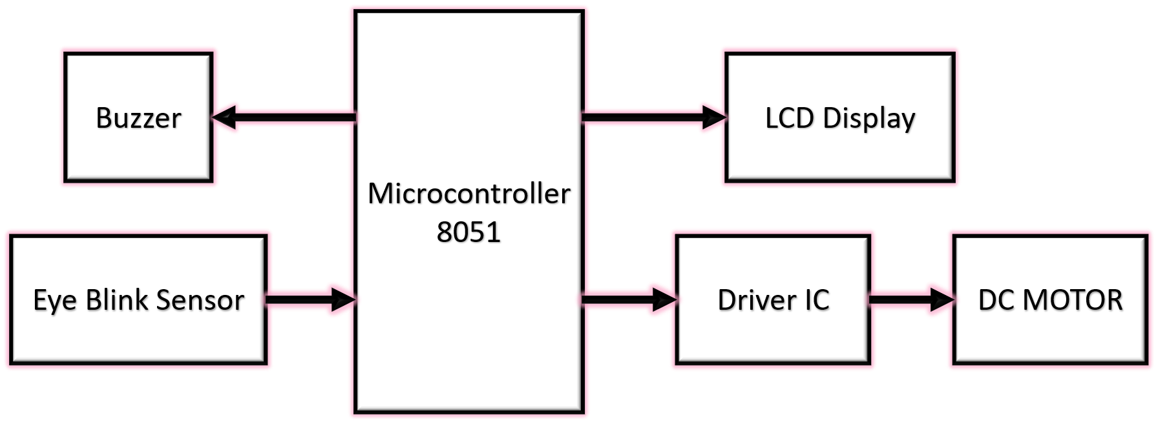

Fig 2.1 Block diagram of driver drowsiness detection system.

#### 2.2 COMPONENTS REQUIRED

1. 8051 microcontroller

Microcontroller is an integrated circuit that contains a microprocessor along with memory and associated circuits and that controls some or all of the functions of an electronic device (such as a home appliance) or system.

1. Driver IC L293D

The L293D is a popular 16-Pin Motor Driver IC. It is mainly used to drive motors. A single L293D IC is capable of running two [DC](https://components101.com/motors/toy-dc-motor) [motors](https://components101.com/motors/toy-dc-motor) at the same time; also the direction of these two motors can be controlled independently.

1. Eye Blink Sensor

The eye blink sensor illuminates the eye with infrared light and monitors the changes in the reflected light. The sensor output is active high for Eye close and can be given

directly to microcontroller for interfacing application (e.g. buzzer)

1. DC motor
   1. Direct Current (DC) motor is a motor that turns energy from a direct current and turns this into mechanical energy. Most electric motors operate through the interaction between the motor's magnetic field and electric current in a wire winding to generate force in the form of torque applied on the motor's shaft.
2. Buzzer

Typical uses of buzzers and beepers include alarm devices, timers, and confirmation of user input such as a mouse click or keystroke.

1. 16*2 LCD display
   1. 16x2 LCD means it can display 16 characters per line and there are 2 such lines. In this LCD each character is displayed in a 5x7 pixel matrix *Driver Drowsiness Detection System*

#### 2.3 CIRCUIT DIAGRAM

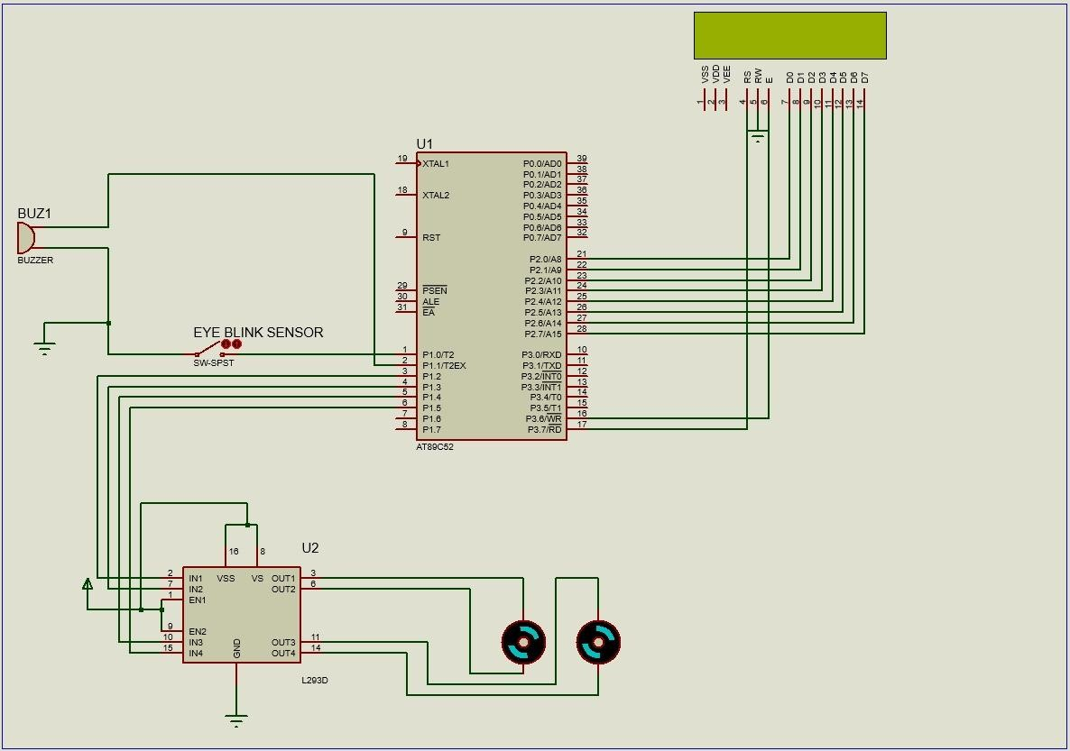

Fig. 2.2 Circuit diagram of ping pong game using arduino

The circuit is built using an 8051 Microcontroller (AT89C52). In the circuit of the driver drowsiness detection system P1.0 and P1.1 of the microcontroller are connected to the eye blink sensor and the buzzer. P1.2, P1.3, P1.4 and P1.5 of AT89C52 are connected as the input of the driver IC. Port 2 of the microcontroller(AT89C52) is connected to the LCD Display. P3.6 AND P3.7 of AT89C52 are connected to the E pin and RS pin of the LCD display. The eye blink sensor detects the movement of the eye of the driver. It detects the orientation, displacement and motion like features and sends the information to the microcontroller. The L293D IC receives signals from the microcontroller and transmits the relative signal to the motors. It has two voltage pins, one of which is used to draw current for the working of the L293D and the other is used to apply voltage to the motors. When the eye blink sensor is at logic 1, the motor is running and the buzzer is in off state thus the LCD display shows 'Driver is not sleeping’ and when the sensor is at logic 0 the motor is off and the buzzer gets high, the LCD display shows 'Driver is sleeping' thus the vehicle stops when the driver is sleeping.

## CHAPTER 3 SIMULATION

#### 3.1 SIMULATION

The software used for simulation is Proteus Design Suite. The Proteus is an electronic circuit design software which includes a schematic capture, simulation and PCB (Printed Circuit Board) Layout modules. The software is used mainly by electronic design engineers and technicians to create schematics and electronic prints for manufacturing printed circuit boards. The Proteus Design Suite is a Windows application for schematic capture, simulation, and PCB (Printed Circuit Board) layout design.

Keil MicroVision is a free software, an integrated development environment (IDE), which integrated a text editor to write programs, a compiler and it will convert the source code to hex files too. The microvision IDE combines project management, run-time environment, build facilities, source code editing, and program debugging in a single powerful environment. µVision is easy-to-use and accelerates embedded software development.

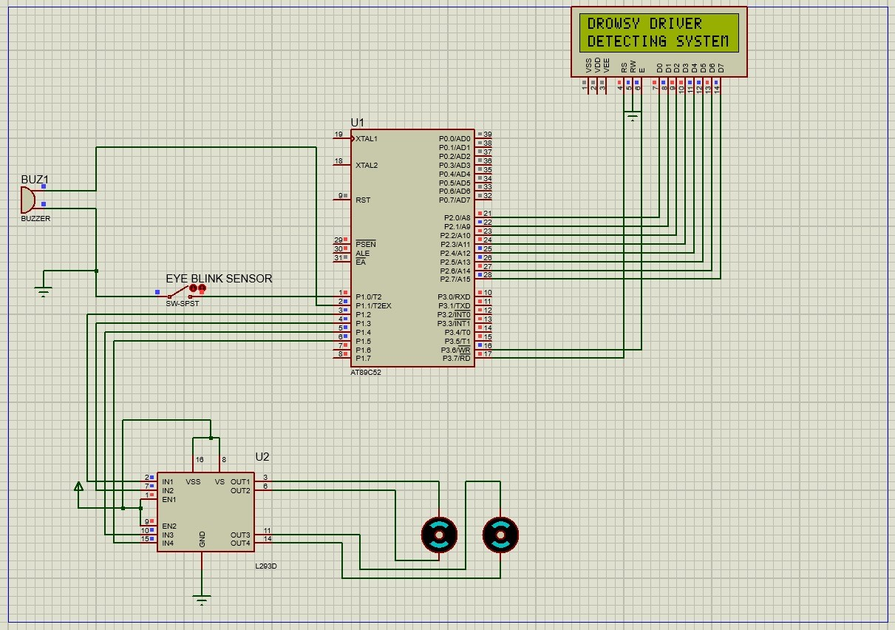

Fig. 3.1 Simulation of driver drowsiness detection system when vehicle is about to start

running

*Ping Pong Game Using Arduino*

When the vehicle moves, the sensors would take the input from the eye blink rate of the driver. These inputs are then sent to the microcontroller. The microcontroller takes various inputs through ports and passes the signals to the output ports so that necessary actions could be carried out. The output of the microcontroller is given to the LCD, and the buzzer. The following gives an account of the outputs. The DC motor attached to the output port is slowed down whenever the driver sleeps. Warning message generated due to the driver drowsiness is displayed on the LCD screen. In this driver drowsiness detection system, the eye blink sensor detects whether the driver is sleeping or not sleeping. The vehicle will stop running when the eye blink sensor detects that the driver is sleeping and the buzzer starts to beep.

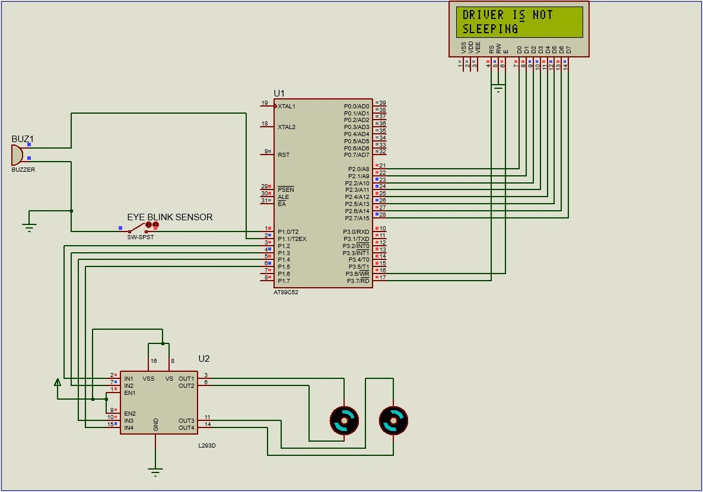

Fig 3.2 Simulation of driver drowsiness detection system when driver is not sleeping

The eye blink sensor is at logic 1 which indicates that the driver is not sleeping, hence the LCD display shows ‘DRIVER IS NOT SLEEPING’ and the same information is passed to the driver IC thus the vehicle continues to run.

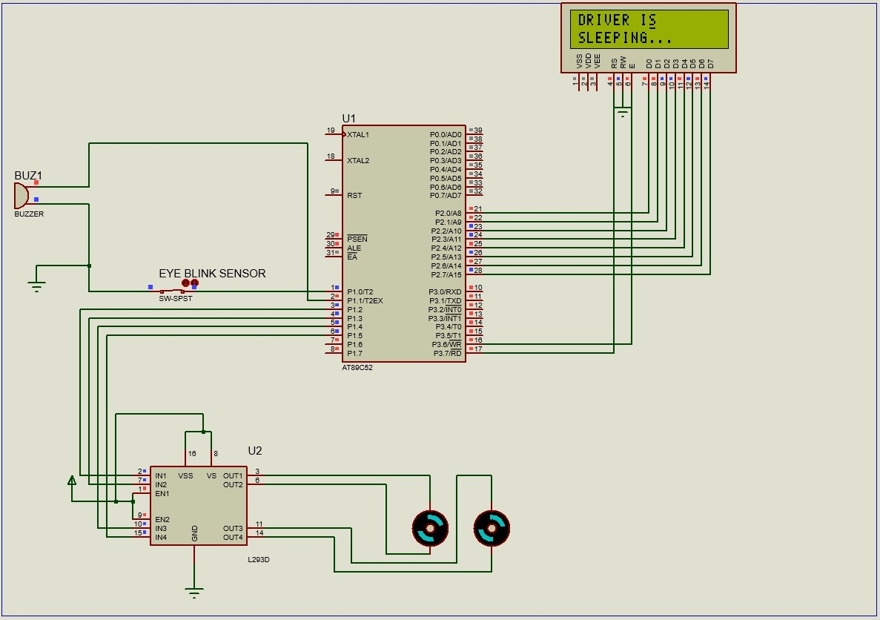

Fig 3.3 Simulation of driver drowsiness detection system when driver is sleeping

The eye blink sensor is at logic 0 which indicates that the driver is sleeping or unconscious, hence the LCD display shows ‘DRIVER IS SLEEPING’ and the same information is passed to the driver IC thus the vehicle stops and the buzzer beeps.

#### 3.2 PROGRAM CODE

#include <regx51.H>

sbit rs =P3^7; sbit en =P3^6; sbit EyeBlinkSensor = P1^0; sbit Buzzer=P1^1;

sbit M11 = P1^2; sbit M12 = P1^3; sbit M21 = P1^4; sbit M22 = P1^5;

void delay(unsigned char a)

{ int i,j;

for(i=0;i<a;i++) for(j=0;j<=1000;j++);

}

void Cmd (unsigned char a)

{

rs=0; P2=a; en=1; delay(10); en=0;

}

void Data(unsigned char a)

{

rs=1;

P2=a; en=1;

delay(10); en=0;

}

void String(unsigned char *p)

{

while(*p)

Data(*p++);

}

void main()

{

M11 = 0;

M12 = 0;

M21 = 0;

M22 = 0;

Buzzer = 0;

Cmd(0x38);

Cmd(0x0E);

Cmd(0x80);

String("DROWSY DRIVER");

Cmd (0xc0);

String("DETECTING SYSTEM"); delay(500);

Cmd(0x01);

while(1)

{

if(EyeBlinkSensor == 0)

{

Buzzer = 1;

M11 = 0;M12 = 0;M21 = 0;M22 = 0;

Cmd(0x80);

String("DRIVER IS ");

Cmd(0xc0);

String("SLEEPING...");

}

else

{

Buzzer=0;

M11=1;M12=0;M21=1;M22=0;

Cmd(0x80);

String("DRIVER IS NOT ");

Cmd(0xc0);

String("SLEEPING");

}

} }

### CHAPTER 4 ADVANTAGES AND LIMITATIONS

##### 4.1 ADVANTAGES

1. The driver drowsiness detection system could differentiate normal eye blink and drowsiness and could prevent the driver from entering the state of sleepiness.
2. The system could detect when a driver becomes sleepy or unconscious and the vehicle slows down or stops which could save the life of the driver as well as reduce the number of accidents caused every year.
3. Monitoring cameras are not required since the eye blink sensor is attached to the driver and this method is practically applicable.

##### 4.2 LIMITATIONS

Limitations of driver drowsiness detection system is that the driver has to wear the eye blink sensor frame while driving. If the driver fails to wear the eye blink sensor, the drowsy driver detection system would not be working.

# CHAPTER 5 CONCLUSION

A ping pong game with Arduino offers a unique opportunity to combine technical skills with creativity. Throughout the project, you learn essential concepts in programming, electronics, and user interface design.The hands-on experience of creating a functional game not only solidifies your understanding of microcontrollers and game mechanics but also encourages innovation as you experiment with features and enhancements. This project can serve as a stepping stone to more advanced projects in game development and robotics, making it a valuable addition to your skill set. By developing the game, you gain valuable skills in coding logic, circuit design, and user interaction. This project also encourages problem-solving as you troubleshoot and enhance gameplay features.The experience of seeing your code come to life and engaging with a playable game reinforces learning and provides a sense of accomplishment. Whether you're a beginner or looking to refine your skills, this project serves as an excellent foundation for exploring more complex game development and electronics applications. Creating a ping pong game using Arduino is a rewarding project that blends creativity, programming, and electronics.

# REFERENCES

1. Nikolaos P, “Vision-based Detection of Driver Fatigue,” Proc. IEEE

International Conference on Intelligent Transportation, pp.45-60, 2000.

1. Zutao Zhang; Jiashu Zhang, “A New Real-Time Eye Tracking for Driver Fatigue Detection,” Proc.2006 6th International Conference on ITS

Telecommunications, pp.8-11, 2006.

1. Grace; Richard, et al. "A drowsy driver detection system for heavy vehicles."Digital

Avionics Systems Conference, 1998. Proceedings, 17th DASC. The

AIAA/IEEE/SAE. Vol. 2. IEEE, pp.50-70, 1998.

1. Ji Qiang; Zhiwei Zhu; Peilin Lan. "Real-time nonintrusive monitoring and prediction of driver fatigue." Vehicular Technology, IEEE Transactions on53.4, 1052-1068, pp.80-90, 2004.
2. Murata; Apsua; Yasutaka Hiramatsu. "Evaluation of drowsiness by HRV measures-basic study for drowsy driver detection." Proceedings of 4th International

Workshop on Computational Intelligence & Applications. Hiroshima: Hiroshima

University, 2008, pp. 38-45.

Department of Electrical and Electronics Engineering, M.A.C.E

*20*